
NOTICE OF APPLICATION MAILING PACKET
SVMC 17.80.110

10210 E Sprague Avenue  Spokane Valley WA 99206
Phone: (509) 720-5240  Fax: (509) 720-5075  permitcenter@spokanevalley.org

PART I – REQUIRED MATERIAL
**THE PLANNING DIVISION WILL NOT ACCEPT YOUR APPLICATION IF THE REQUIRED MATERIALS ARE NOT PROVIDED**

Title Company and Applicant Certification
Spokane County Assessor’s half section map with subject parcel(s) outlined. (The properties may be located on more than one ½ section Assessor’s map and all shall be submitted.)
Submit a property profile for each adjacent parcel included in the noticing.

All stamped and addressed envelopes with the following;
- Minimum envelope size of 9.5” x 4.13”
- Address of property owner
- Parcel number
- Stamp
- Leave return address area blank.

PART II – INSTRUCTIONS

STEP 1:
Obtain Assessor’s maps from Spokane County Assessor’s Office, first floor, Spokane County Courthouse or www.spokanecounty.org/assessor/. Identify the boundary of the proposed site with a solid red line. If the owner of the property also owns any abutting parcels, identify these with a dashed red line. (SEE EXAMPLE 1).

STEP 2:
Take the Assessor’s map(s), the “Title Company and Applicant Certification” to any local Title Company to obtain a title search of all of the adjacent properties (directly touching subject property, across public right-of-way and kiddy corner) to the property(ies) indicated by the solid or dashed red line (SEE EXAMPLE 1). All pages (property profiles) accompanied with the title company search shall also be submitted. Note: The Assessor’s map(s) and the title company search shall be current within sixty (60) days of issuing the notice of application.

STEP 3:
Utilizing the addresses obtained in STEP 3, stamp and address each envelope (SEE EXAMPLE 2). At the appropriate time, Planning Division will prepare and mail the Notice of Application to those property owners addressed on the envelopes. Note: The applicant is responsible for verifying the completeness of the Title Company’s ownership/taxpayer list against the Assessor’s map(s) and must certify this with the “Title Company and Applicant Certification” form.

NOTE: The above required material must all be submitted before commencing noticing. If you fail to fill out the information appropriately and not submit everything required in ‘STEP 3’ above,

PL-33 V1.0 Page 1 of 3
your application will be put on hold until such time it is corrected. For additional information or questions, call the Planning Counter at (509) 720-5310.

EXAMPLE 1:
NOTIFICATION AREA AND MAILING (Assessor’s Section Map with Site and adjacent property owners as required for noticing.)
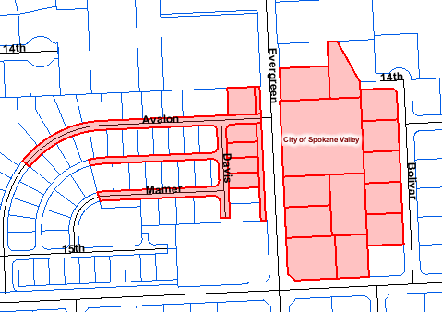
SITE

EXAMPLE 2:
INSTRUCTIONS FOR PREPARATION OF ENVELOPES FOR NOTICE OF APPLICATION;

All owners/taxpayer of adjacent properties shall receive a stamped-addressed envelope. If there is more than one owner, with separate addresses, a stamped-addressed envelope will need to be prepared for both.

Parcel No. 45222.9912
Sally Citizen
12340 East Sprague Avenue Spokane Valley, WA 99206

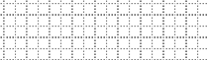
  - Minimum envelope size 9.5” x 4.13”
Return address area
LEAVE BLANK
  - Address of owner
  - Parcel Number
  - Stamp
  - Return address area left blank

MEMORANDUM

TO: Title Company
FROM: Department of Community Development, Planning Division
SUBJECT: Notice of Application Owner/Taxpayer List

Please furnish a list of the owners and taxpayers of record of all properties adjacent to the proposal (or total adjoining ownership; including optioned land, to the extent known) as outlined on the accompanying Spokane County Assessor's map(s).

FILE NO. :

PART III
TITLE COMPANY AND APPLICANT CERTIFICATION

TITLE COMPANY CERTIFICATION

I do hereby certify that the following list of names and addresses, consisting of the attached pages from the Spokane County Assessor's or Treasurer's most current computer records, is to the best of my knowledge correct.

I also certify I have provided loan numbers, if possible, when the owner is listed as a finance company.

Signed by: Date:
(Title Company Official)

For:
(Company Name)

APPLICANT CERTIFICATION

I, the applicant or agent for the applicant, have verified the attached ownership list with the attached Assessor's map(s) and find that all tax parcel numbers adjacent to the project site, including owned or optioned land as shown on the Assessor's map(s) have been listed by the Title Company.

Applicant:
(Print Name)

Signed by: Date:
DISCLAIMER: By accepting this permit and proceeding with the work, the applicant/permittee and owner acknowledges and agrees that: 1) If this permit is for construction of or on a dwelling, the dwelling is/will be served by potable water. 2) Ownership of this City of Spokane Valley permit inures to the property owner. 3) The applicant/permittee is the property owner or has full permission and authority to represent the property owner in this project and carry out the work specified in the permit. 4) All construction is to be done in full compliance with the City of Spokane Valley Municipal Code. The applicable codes are available for review at the City of Spokane Valley Permit Center. 5) The applicant/permittee further declares that they are either: (A) a contractor currently registered and properly licensed in accordance with Chapter 18.27 RCW; (B) the registered or legal owner or authorized agent of the property for which I am applying for permit and not a licensed contractor; or (C) otherwise exempt from the requirements set forth in RCW 18.27.090 and will abide by all provisions and conditions of the exemption as stated. 6) The City of Spokane Valley permit is a permit to carry out the work as specified therein and is not a permit or approval for any violation of federal, state or local laws, codes or ordinances. 7) Compliance with all federal, state, and local laws shall be the sole responsibility of the applicant/permittee and property owner. 8) Plans or additional information may be required to be submitted and subsequently approved before this application can be processed. The City is not responsible for any code violation through the issuance of this permit. 9) Failure to request and obtain the necessary inspections and inspection approvals may necessitate stoppage of work and/or removal of certain parts of the construction at the applicant's/permittee's or property owner's expense.

